**CHAPTER 1**

**INTRODUCTION**

**1.1 OVERVIEW**

Role of Artificial intelligence plays major role many fields especially in the areas where the human intervention or human error is to be avoided. This need not even left the gaming field also ,the reason is people are tired of playing with traditional computer opponent so they wanted to play with the human opponent so there came the need for multiplayer online and offline games ,But later the online multiplayer games where over flown with online players. This too didn't last for long because of the players busy schedule players who want to play in their free time didn't find the other players online ,so there came a need for the AI to act in the place of human player. This project is a multi player snake game in which two player compete each other on a single board.

This AI substitute of the human player should allow the opponent players to win as well as to loss . So the AI should be build in such a way that it plays like a actual human player. This project has developed a AI to capture the food and to escape from the opponent's attacking moves and patterns he follows to defeat his opponent.

The bigger challenge in this project is the data collection from the user and facilitating the players to player with their friend ,So thinking of the better way to connect the people the first thing that comes to our mind is the web technologies which has played and being playing a major role many field like banking ,entertainment ,medicine and education. So a better platform to implement this idea is the web technologies

Now the disclosed information is that the project is entire depend on web technology ,but how the a web technology is going to serve a need of the gaming project because the gaming need a lots of data to be transferred over the network for smooth and clean gaming experience with the friends and strangers.

This need is satisfied by the many server push mechanisms ,one such mechanism formulised is SSE(Server Sent Events). The next challenge is the data storage and collection .The better way to store the data in a web environment is the database ,this project uses the MySQL database to store the data and also for retrieval ,manipulation and updation of data.

**1.2 MULTIPLAYER SNAKE GAME**

This Snake game is mainly focused on the multiplayer mode rather than the single player mode. The major challenge of the multiplayer mode over single player mode is the end point of the game .In single player mode the end point of the game is none ,it depend on the player's ability and only the score matters but in multiplayer mode the end point is entirely different ,any one of the snake should stand or both should fall so the end point is led by attacking each other ,even if they don't attack the game board cannot accommodate their body after they eat several food. In this multiplayer concept the player can attack each other ,if one player attack the other at particular body part then the parts after that will be discarded ,in this way their body part will be reduced and the one with body part less than the desired level will be declared as lost and the other as winner. Here a doubt may arise, then how will they develop their body part .This operation is done by consuming the food displayed in the board. This food is also distributed in synchronised manner that is both the players will get same food at same co-ordinates and there is no different weightage for different food, every food will have same weightage .

**1.3 CHARACTERISTICS OF THE MULTIPLAYER SNAKEGAME**

Received moves as result of the several games played by the player among their friends more and more amount data were got accumulated in the database which could be properly maintained and manipulated to give excellent user experience .This data is collected while the player gives any moves to their snake in any given situation .Thus the collected data is used by the computer during the game play with the other human player ,for example consider both the player and the computer are approaching for a food now the human player will have clear idea of what he/she should do but a computer will not have such an idea or do not have any prediction of the opponent’s next move ,so to make the computer comfortable with the opponent human player these data gives wide view for the computer. Some more characteristics that are added are to this game is that the computer snake reveals its current state that is it change its snake colour when it can predict the opponent’s next move and change to another colour when it cannot predict the opponent’s next move. The reason to have this feature is to increase the curiosity of the opponent player so that his interest in the game increases and he/she give their valuable move data to computer for its future use.

This game follows the steps below:

1- Collect the data from the user by a multiplayer game session.

2- Do some prediction job when a situation is met .

3- Uses the predicted data to escape from the opponent.

**1.4 SERVER PUSH MECHANISM FOR MULTIPLAYER GAME**

The first model proposed is entirely a server oriented model in which the entire game data is maintained in the server side and continuously sent as a event stream to the client, the major drop back of this model is the efficiency in term of both time and space occupied by the data transferred over the network. The reason for this failure is due to the enormous amount of object created by the both client and server. This failure is overcome by the second model which completely localized the to the individual client machines by the client agent like browser. This model has improved the efficiency of the client as well as the server which should serve the several similar clients. So here come the need for the synchronization because the game is left to the individual client and only some data are sent to the server regarding the multiplayer session.

**1.5 PREDICTION FOR BOT**

In this project the prediction is done to guess the human opponent’s next move and make a relevant action to the computer snake. This prediction is basically done by calculating the likelihood of any given classes. This game involve totally four classes they are left ,right ,top and down .These four classes are classified based on eight parameters they are head position of the snakes and distance between food and snake and length and current direction of the snake.

**1.5.1 Database for Prediction Model**

**Moves database**

This is the database which contains various moves made by the player in their previous games, the attributes of the subject relation are headx1,heady1,l1,d1,id1,id2,d2,l2,dixs,diyx,dix1f,diy1f and game board id.

**CHAPTER 2**

**LITERATURE SURVEY**

|  |  |
| --- | --- |
| **2.1** | **SLITHER.IO** |

***Slither.io*** is a massively multiplayer video game available for iOS, Android, and web browsers, developed by Steve Hawse. Players control an avatar resembling a worm, which consumes multicolored pellets, both from other players and ones that naturally spawn on the map in the game, to grow in size. The objective of the game is to grow the longest worm in the server. *Slither.io* is similar in concept to the popular 2015 web game *Agar.io* and is reminiscent of the classic arcade game *Snake*.

The game grew in popularity following its promotion among several prominent YouTube users such as Pew Die Pie, and topped the App Store shortly after its release. *Slither.io*'s browser version was ranked by Alexa as one of the 1,000 most visited sites by July 2016, while the iOS version ranked first in the most downloaded apps on the App Store. A mobile version of the game for Android was released on March 27, 2016. The reception of the game was positive, with reviewers praising its appearance and customization but criticizing it for its low replay value and the high price users must pay to remove advertisements.

**2.1.1 Development**

According to game creator Steven Hawse, he was inspired to create the game while he was experiencing financial problems. As a result of these financial issues, he had to move from Minneapolis to Michigan, where he realized the popularity of *Agar.io*. He had long wanted to create an online multiplayer game, but the only option for the development at the time was in Adobe Flash, and not wanting to use this method, he gave up the idea for a while. Hawse finally created the game when he realized that Web Socket, a low-latency protocol supported by most major browsers, was sufficient and stable enough to run an HTML game similar to other games such as *Agar.io* The most difficult part of the development was in making each server stable enough to handle 600 players at a time. Hawse struggled to find space on servers with enough space in regions where there was more demand and tried to avoid cloud services like Amazon Web Services, owing to the high cost that these services would incur based on the amount of bandwidth used .

After six months of development, *Slither.io* was released for browsers and iOS on March 25, 2016, with servers supporting up to 500 players Two days after the iOS/browser versions' release, an Android version was made available by Low-tech Studios. The only way Hawse could make revenue was to display advertising in the app after the player's worm died; this option could be removed for US$3.99. He chose not to sell virtual currency or power-ups so that those who paid would not have an advantage over players who did not. As there was no money to advertise for the game, the only way to advertise was the various *let's plays* by players on YouTube, including Pew Die Pie, who had more than 47 million subscribers at the time .

**2.1.2 Advantages and Disadvantages**

* More than two player can compete on a single board which pretty much larger.
* Disadvantage is that it is easy to kill other player and get killed by other players.

**2.1.3 Screenshots**

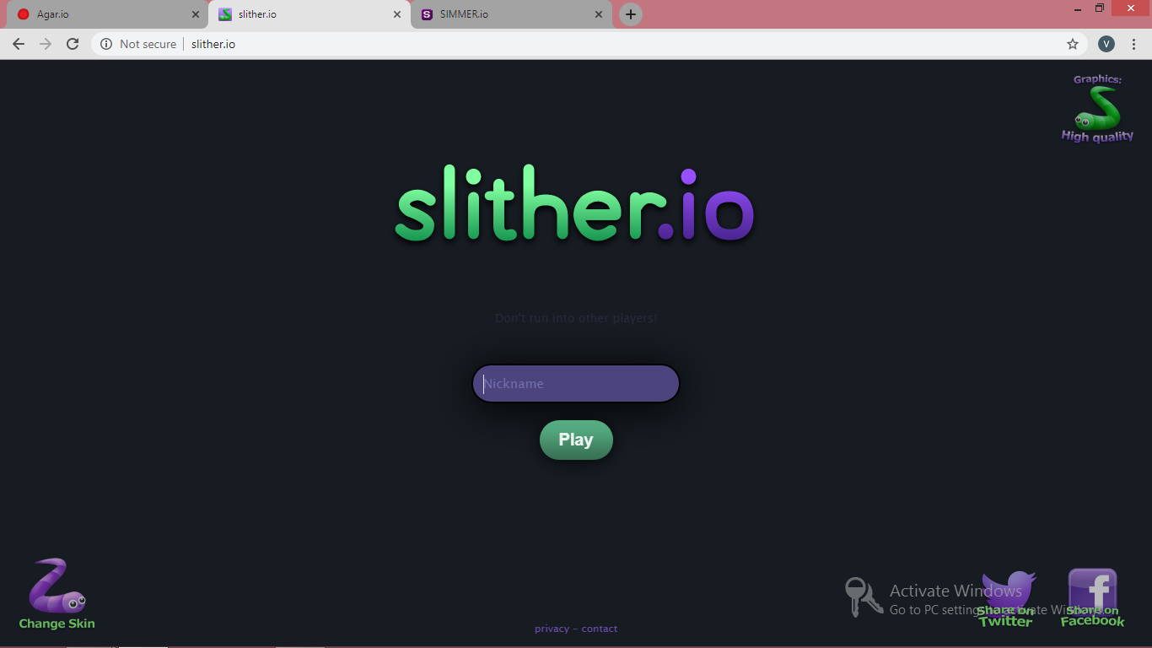

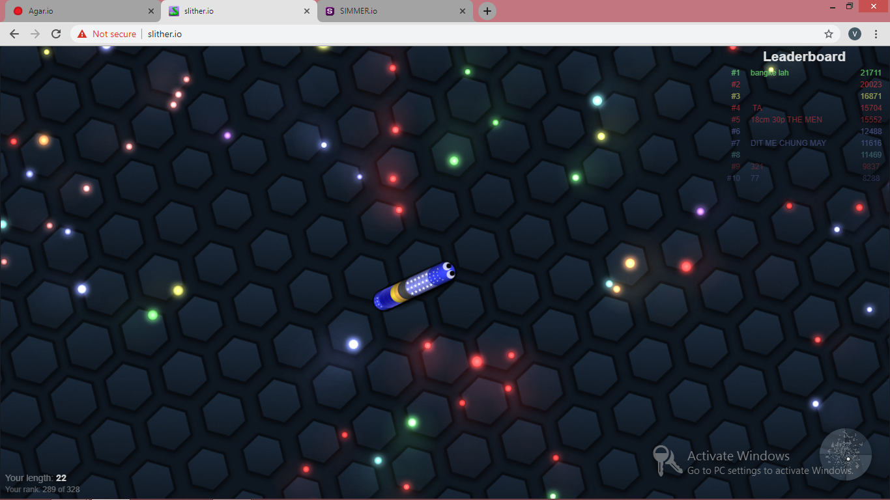

|  |  |
| --- | --- |
| **2.2** | **AGAR.IO** |

***Agar.io***is a massively multiplayer online action game created by Brazilian developer Matheus Valadares. Players control one or more cells in a map representing a Petri dish. The goal is to gain as much mass as possible by eating agar and cells smaller than the player's cell while avoiding larger ones which can eat the player's cells. Each player starts with one cell, but players can split a cell into two once it reaches a sufficient mass, allowing them to control multiple cells. The name comes from the substance agar, used to culture bacteria.

The game was released to positive critical reception; critics particularly praised its simplicity, competition, and mechanics, while criticism targeted its repetitive game play. Largely due to word of mouth on social networks, it was a quick success, becoming one of the most popular web and mobile games in its first year A Steam version was announced on 3 May 2015 (though never released as of May 2019), while the mobile version of *Agar.io* for iOS and Android was released on 24 July 2015 by Miniclip. *Agar.io* has inspired similar web games called ".io games", including games with a similar objective but different characters, and games that incorporate elements of other genres like shooter games

## **2.2.1 Development**

*Agar.io* was announced on 4chan on 28 April 2015 by Matheus Valadares, a 19-year-old Brazilian developer Written in JavaScript and C++, the game was developed in a few days The game originally did not have a name, and users had to connect to Valadares' IP address in order to play. The name *Agar.io* was suggested by an anonymous user on 4chan, as other domain names such as cell.io were already taken. Valadares continued updating and adding new features to the game, such as an experience system and an "experimental" game mode for testing experimental features. One week later, *Agar.io* entered Steam Greenlight with Valadares announcing a future free-to-play version of the game for download. He planned to include features in the Steam version not available in the browser version, including additional game modes, custom styling, and an account system. It was approved for listing on Steam due to community interest. However, the Greenlight program was shut down in 2017,[]](https://en.wikipedia.org/wiki/Agar.io#cite_note-18) and the announced game has yet to be released.

On 24 July 2015, Miniclip published a mobile version of *Agar.io* for iOS and Android. Sergio Varanda, head of mobile at Miniclip, explained that the main goal of the mobile version was to "recreate the gaming experience" on mobile, citing the challenges with recreating the game on touch screen controls

**2.2.2 Advantages and Disadvantages**

* It has more user accommodation capacity and improved input control.
* The basic functionality of the game is less.

**2.2.3 Screenshots**

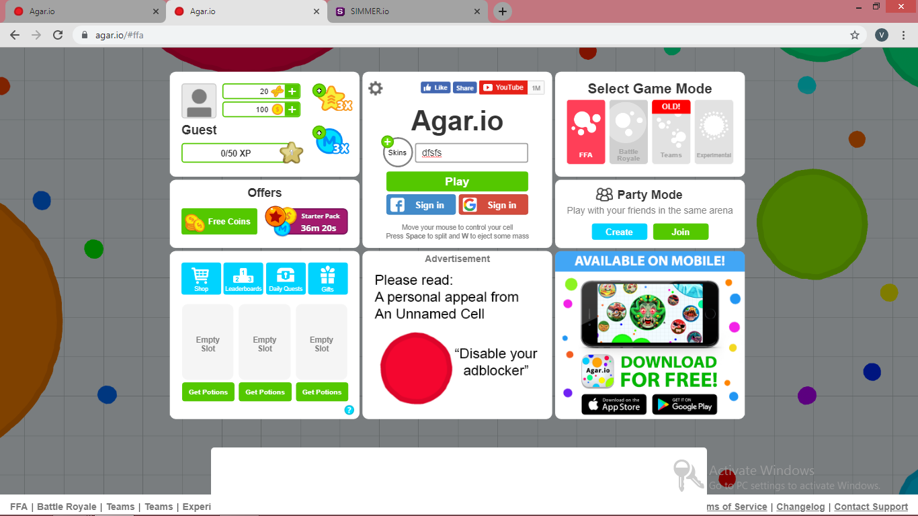

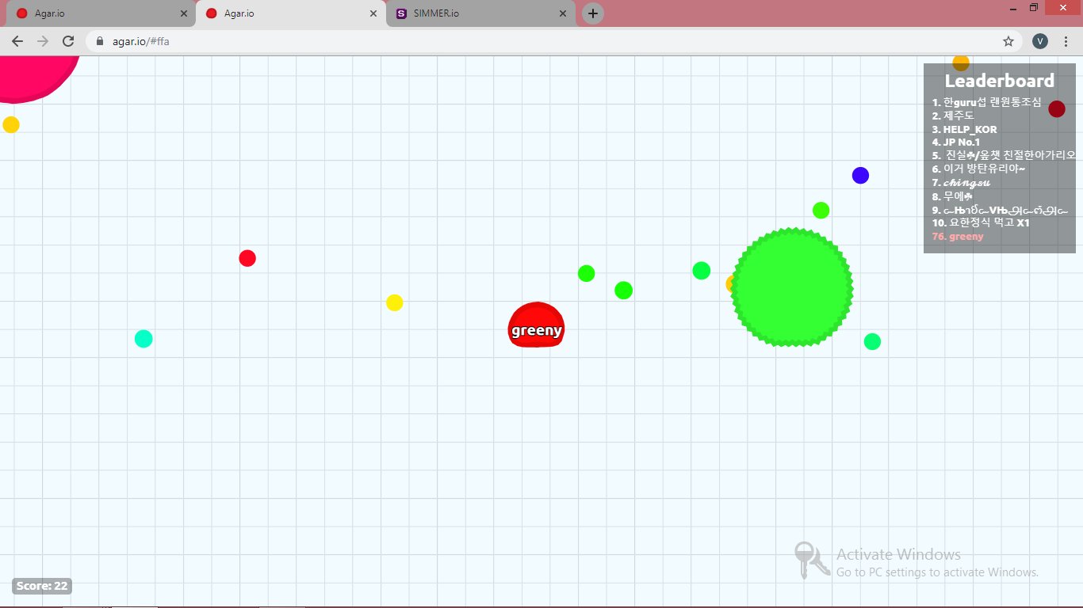

**CHAPTER 3**

**PROPOSED WORK**

**3.1 RECOMMENDED METHOD**

Aim of this project is to develop a game to enable the player to meet online and search for person using his nick name and have a friendly game with him ,this purpose has been completely served by this game by a server push mechanism called the SSE and flag method to do the as multiplayer

**3.1.1 Advantages**

* The first advantage of this method is that it is light weight
* Usually any prediction system would require a basic dataset scrapped from somewhere but here there is no need for that since the entire data set has been generated by the customer .
* Anyone can play from anywhere by having the access to the network only ,this is possible through several networking job done in the system in deeper level.
* Thought there are no online players are available for a while there is no need for user to sit idle he/she can play a game with computer in the mean waiting while ,which will also improve knowledge base of the computer.
* The next big advantages of this model is knowledge capturing is done by the system automating when players are playing the game ,that is there is no separate predefined or trained data set is needed.
* Since the game is localized to the client machines the game is very much responsive that any other snake game available in .io game collection

**3.2 PROPOSED ARCHITECTURE DIAGRAM**

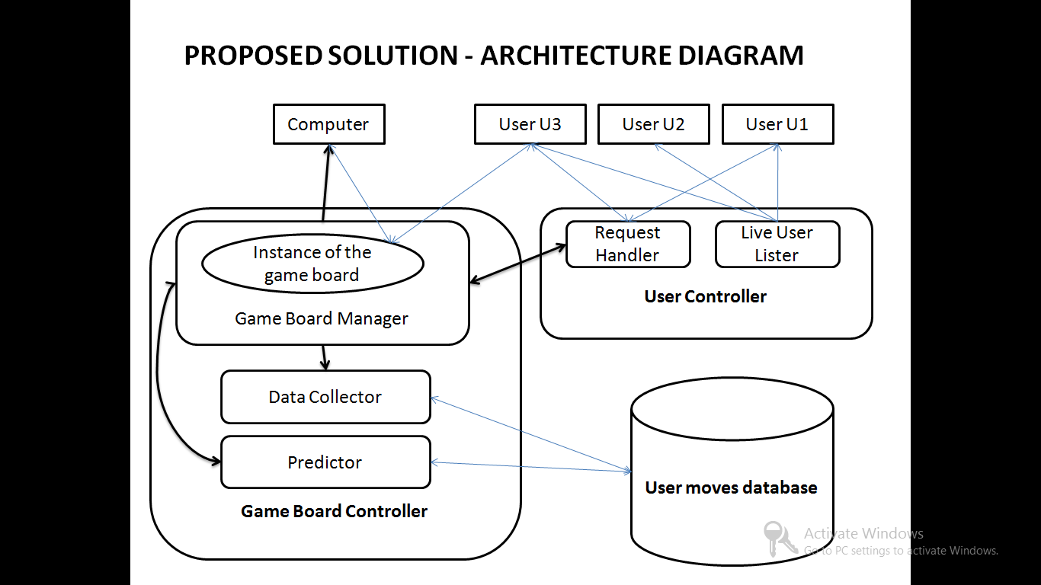

**Figure 3.1 Architecture Diagram**

**3.3 DESCRIPTION OF THE ARCHITECTURE DIAGRAM**

**3.3.1 Participants**

The participants of this game can either be a human or a computer since it has feature of single player against the computer and multiplayer mode which has player playing against a another player so the participant can be a human player or a computer.

Every feature that involves the rela data flow from server to client has any touch of the HTTP server push job so let us first look into the mechanisms available for the HTTP server push job ,There are several mechanism developed for this purpose some of them are

* Server Sent Events
* Long/Short polling
* Web sockets
* COMET

Building a real-time web application is a bit challenging one, where we need to consider how we are going to send our data from the server to the client. Technologies that enable this “proactively” have been around for quite some time and are limited to two general approaches: *client pull*or *server push.*

A few ways to implement these:

* Long/short polling (client pull)
* WebSockets (server push)
* Server-Sent Events (server push)
* Client pull — client asking server for updates at certain regular intervals
* Server push — server is proactively pushing updates to the client (reverse of client pull)

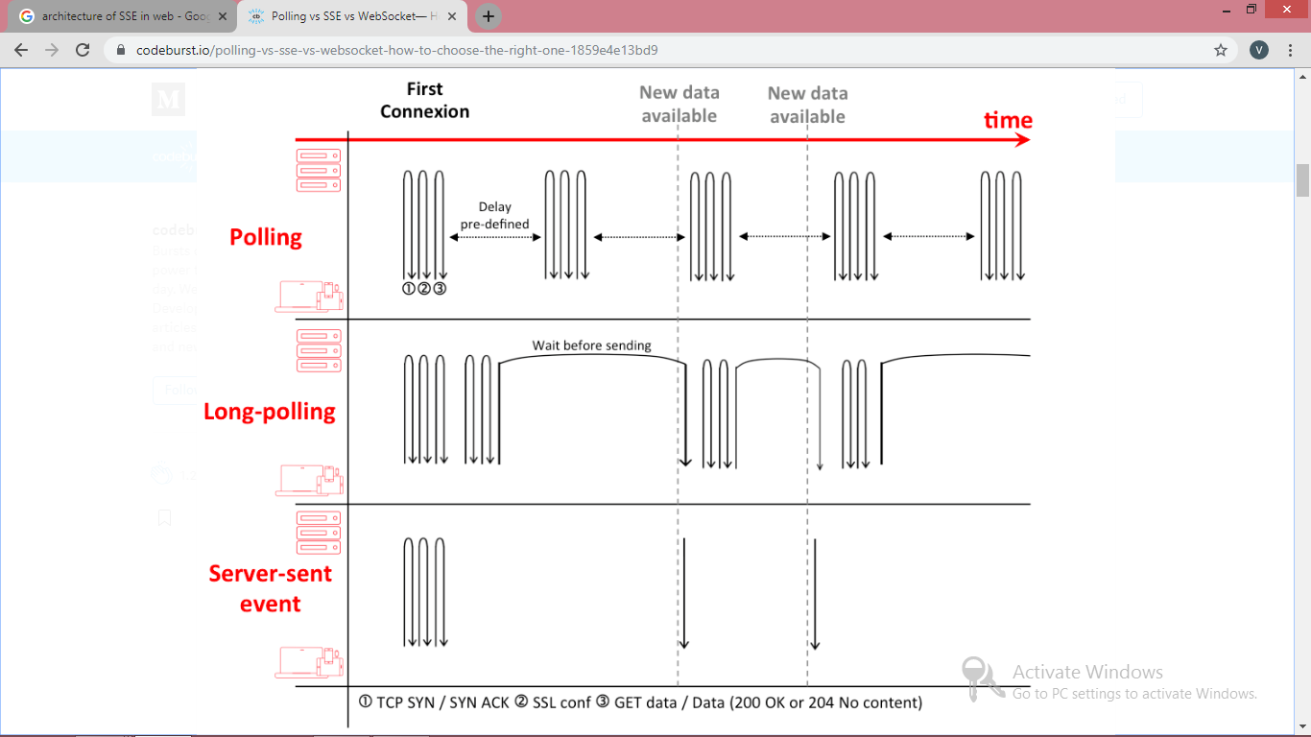

**Figure 3.2 Comparison of server push mechanisms**

For better user experience the request and response process should be carried out only on asynchronous manner ,that too in the background because if the browser handles these process then it will degrade the performance of the game .This degradation occur because in JS every process is a single threaded process so if we frequently send and receive the data through the browser space then it will make it clumsy.

To overcome this problem we introduce a AJAX call for background process ,AJAX call overcome this problem by using the AJAX engine which handle the request and response instead of the browser.

A typical AJAX architecture looks like:

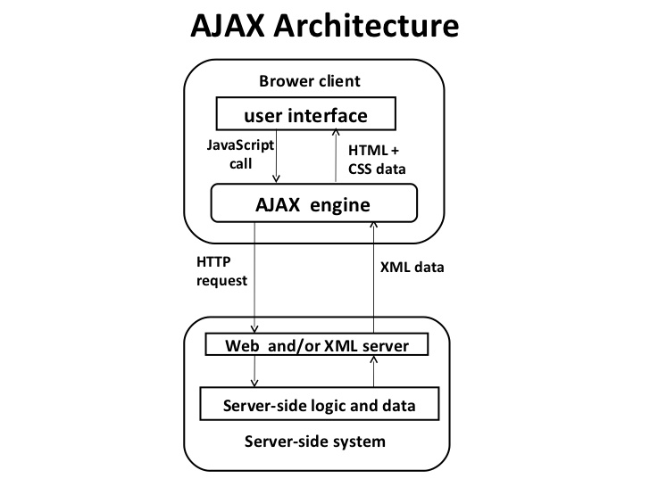

**Figure 3.3 AJAX Architecture**

There are some disadvantages to this AJAX architectural design. These disadvantages or drawbacks have been overcome by the other techniques in the project.

AJAX stands for **A**synchronous **Ja**vaScript and **X**ML. AJAX is a new technique for creating better, faster, and more interactive web applications with the help of XML, HTML, CSS, and Java Script.

1. Ajax uses XHTML for content, CSS for presentation, along with Document Object Model and JavaScript for dynamic content display.
2. Conventional web applications transmit information to and from the sever using synchronous requests. It means you fill out a form, hit submit, and get directed to a new page with new information from the server.
3. With AJAX, when you hit submit, JavaScript will make a request to the server, interpret the results, and update the current screen. In the purest sense, the user would never know that anything was even transmitted to the server.
4. XML is commonly used as the format for receiving server data, although any format, including plain text, can be used.
5. AJAX is a web browser technology independent of web server software.
6. A user can continue to use the application while the client program requests information from the server in the background.
7. Intuitive and natural user interaction. Clicking is not required, mouse movement is a sufficient event trigger.
8. Data-driven as opposed to page-driven.
9. Not easy to replace components - It is very difficult to replace any component with a better design or performance without affecting the whole architecture.

**3.3.2 LIVE USER LISTING**

The first phase of the project is the data collection from the user which is done by the game played between the human player. These human player knows each other to give the challenge request to the desired player .To make the player know each other ,the of live users should be displayed to the each individual player.

The other reason to have the live user listed is to enable the users to give request to the other player ,then the request have to be handed over to the recipient player which is done by request handler mechanism

**3.3.2 REQUEST HANDLER**

After the request is being given to a desired player it is handled by a mechanism called 'request handler' ,this mechanism adds the request to the request box the recipient player along with two buttons ,one stating accept and the other stating decline.

Both the accept and decline operation are handled by the request handler. if a player selects accept then a accept signal for the corresponding request is sent to the request handler and further actions are taken if the player clicks decline then the particular request is removed from the request queue of the particular player.

**3.3.3 GAME BOARD MANAGER**

The major task of the game board manager starts after the player click accept button and the accept signal being sent to the request handler ,after receiving the accept signal from the recipient player the request handler change the status of the both player to busy state and then transfer the control to the game board manager

The game board manager check for the status of the both players and life left for the player and then proceed with creating a instance of the game board for the player to have their game. In addition to this ,the game board manager check the game type also (that is whether it is ordinary game or opponent is a bot) so if it is bot it sets the opponent player as a bot or else it will set the opponent player as a object representing the human player.

**3.3.4 DATA COLLECTOR**

The important job of the data collector is the data collection from the user through their moves. Whenever a key is pressed and AJAX call with following data is sent to the data collector module

1. JSON Object of red snake.
2. JSON Object of blue snake.
3. Head position of red snake.
4. Head position of blue snake.
5. Length of both the snake.
6. Current moving direction of both the snakes.
7. Distance between the X co-ordinates of the snake heads.
8. Distance between the Y co-ordinates of the snake heads.
9. Distance between the food and the snakes.

The greater advantage of this kind of data collection is no need for the data cleaning since every data being collected is being gathered consciously and only required data is collected. The JSON object of the snakes have the following attributes

1. User ID it belonged to.
2. Array of body parts object.
3. color of the snake.
4. current moving direction of the snake.
5. winning flag value of the player operating the snake.

Below shown is the code snippet of the JSON object 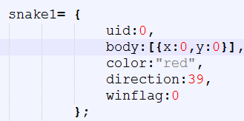

**3.3.5 PREDICTOR**

The predictor module is basically used for predicting the user's next moves ,without this module the computer would be just a path finding snake because only this helps the computer snake to predict the user's next move in advance and helps it make a better move. This module is not active all the times it get activated occasionally because there is no need to predict the opponent's move always ,the need for prediction occurs only in the following situations

1. When a opponent approach the food.
2. When opponent entered the imaginary boundary of the comp snake.

An imaginary boundary is covering the computer snake in all the four direction once the presence of the enemy snake is found inside the boundary the current game board situations are sent to the predictor module for prediction of the opponent's next move. The data sent for prediction include the following

1. JSON object of the both the snakes.
2. DIXS - difference in X co-ordinates of the both snake's head.
3. DIYS - difference in Y co-ordinates of the both snake's head.
4. DIX1F - difference in X co-ordinate of the opponent snake's head and X co-ordinate of the food.
5. DIY1F - difference in Y co-ordinate of the opponent snake's head and Y co-ordinate of the food.

**3.3.6 USER MOVE DATABASE**

The role of the user move database is to store the moves given by the users while playing the game ,this database consist of only one table ,that is next move table .This table include some of the important attributes used for prediction like dixs ,diys ,dix1f and diy1f.This table totally consist of the seventeen attributes in which some are insignificant in the current required of the project they are ,game board ID,ID of the first player and ID of the second player

The structure of the next move table is given below

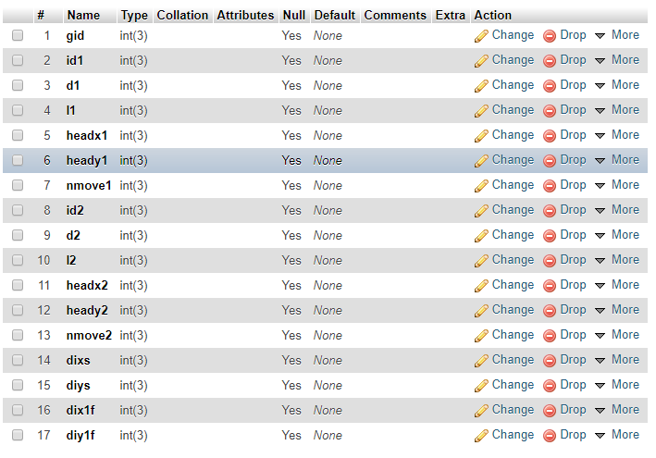

**CHAPTER 4**

**SYSTEM REQUIREMENT**

**4.1 HARDWARE REQUIREMENTS**

PROCESSOR : AMD A4-4300 2.5GHz

HARD DISK DRIVE : 50GB

RAM : 2GB

**4.2 SOFTWARE REQUIREMENTS**

OPERATING SYSTEM : Windows 7 and above

FRONT END : HTML, CSS3

BACK END : Java 8, Java servlet 3.0

SESSION STORAGE : Local Session storage

DATABASE : MySQL 5.7

APIs : MySQL J connector ,org.JSON ,servlet

**CHAPTER 5**

**IMPLEMENTATION MODULES**

**5.1 LOGIN SERVICE**

**5.1.1 Description**

One of the main arguments of introducing an API Gateway is handling cross cutting concerns like authentication, authorization and security which are handled using JSON Web Token (JWT) tokens.

In the web-based exam system, the user name and the password are the keys of the system to identify a specific user. Since any person with the user name and the password is considered to be authorized to access into the system, the information security is critical. The system can automatically generate a token for students registered and send this information to parties in a secure way.

JWT authentication process can be broken into following four steps-

1) User is validated against database and claims are generated based on user’s role.

2) Payload containing claims or other user related data is signed with key to generate token and passed back to user.

3) User sends this token with each request, normally in header or cookies and then received token is decrypted to validate claim.

4) Once user is identified, User is allowed to access Resource server based on his claim.

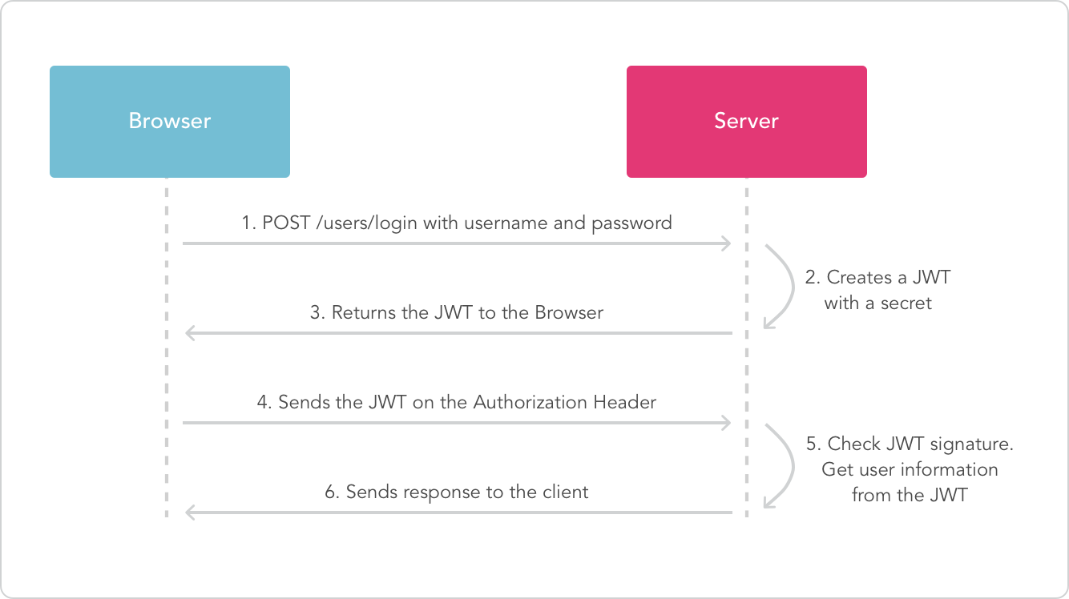

**Figure 5.1 Authentication using JWT token**

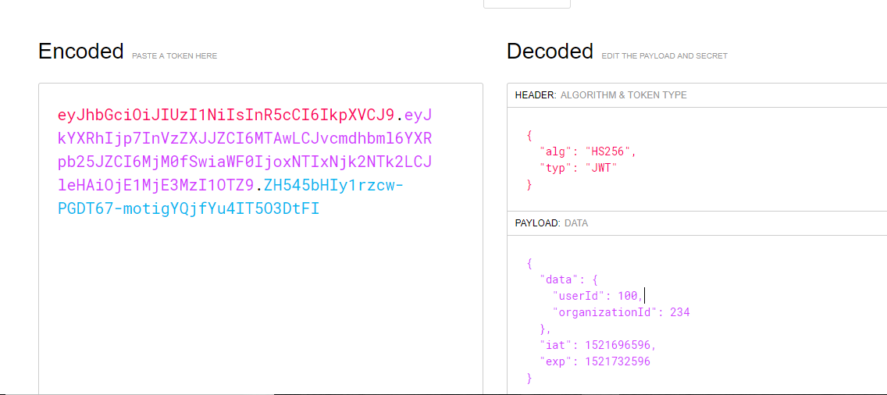

**Figure 5.2 Encoding the Payload**

**Generating JWT Token**

// if user is found and password is right  
 // create a token with only given payload  
 // we don't want to pass in the entire user since that has the password  
 const payload = {  
 admin: user.admin

};  
 var token = jwt.sign(payload, app.get('superSecret'), {  
 expiresInMinutes: 1440 // expires in 24 hours  
 });  
  
 // return the information including token as JSON  
 res.json({  
 success: true,  
 token: token  
 });

**Verifying JWT Token**

// check header or url parameters or post parameters for token  
 var token = req.body.token ;  
 // decode token  
 if (token) {  
 // verifies secret and checks exp  
 jwt.verify(token, app.get('superSecret'), function(err, decoded) {   
 if (err) {  
 return res.json({ success: false, message: 'Failed to authenticate token.' });   
 } else {  
 // if everything is good, save to request for use in other routes  
 req.decoded = decoded;   
 next();  
 }  
 });  
 } else {

// if there is no token, return an error  
 return res.status(403).send({   
 success: false,   
 message: 'No token provided.'   
 });

}  
 });

**5.2 ORGANIZATION SERVICE**

**5.2.1 Description**

There are three types of users in the system: System administrator, Super Admin of the organization registered and other users of the organization. System administrator has the authorization to add super admins.

Super admins are authorized to define other users of the organizations. Super admins and users of the organization can add and modify the questions, change student passwords, edit questions, access exam results, transform exam results into the excel form for further analysis, and send messages to parties. When students access into the system, they see the exams they are required to take; they can take these exams; and they can view their exam scores.

**5.3 QUESTION SERVICE**

**5.3.1 Description**

This section deals with the way the questions are selected for the exam. Along with that it maintains a questions bank where addition, updation and deletion of questions can be performed.

There are three kinds of systems for paper generation:

(1) the database will be viewed as the questions set for selection by examiners

(2) the test paper set will be used for random selection;

(3) automatic paper generation will be implemented using an adaptive strategy.

The first and second systems are able to guarantee quality. But the first one works similarly to manual operation, while the second limits the number of papers. The third type uses random selection and could form thousands of papers almost without limitation. Under the control of the state space, a random selection method may be proved to carry out a large number of invalid operations in the dead cycle, which eventually leads to the failure of the examination papers. The adaptive genetic algorithm has intelligent search technology with global optimization. Good convergence characteristics can work well for meeting the requirements for automatic test papers. Along with automatic questions selection, the organizations can have their own question bank. The adaptive algorithm can pick questions only form the questions uploaded by the organization. The organizations can have their questions as public to all organizations and private only to their organizations. They can add or delete or update the questions at any point of time.

function authenticate(request) {

token = getTokenFromHeader();

if(token) {

userDetails=getUserIdFromToken(token);

if(userDetails === -1) {

// unauthorised user

return 401;

}

// valid user

return true;

}

else {

// bad request

return 400;

}

}

function getQuestions(request) {

authenticateResult = authenticate(request);

if( authenticateResult == true) {

fetch questions from database;

apply the selected filters;

return the questions as response;

} else if (authenticateResult == 401) {

return 401-response;

} else if (authenticationResult == 400) {

return bad-request-response;

}

}

**5.4 EXAM SERVICE**

**5.4.1 Description**

Exam session service deals with the entire flow of the examiner creating an exam. It includes creating an exam template and adding questions.

Exams can be created by two different methods.

In the first method, examiner can create an exam by selecting as many as questions they need with a certain difficulty level from the question pool that they previously created by entering questions with different difficulty levels. While the exam is being created, which group to take it is predetermined. Thus, students view the exam created for them when they access into the system. On the other hand, in the second method, the lecturer lists all questions recorded in the question pool for the relevant exam, then selects the desired questions among them.

Exam Template can be created by two different methods.

In the first method, creating a new template which includes the examiner defining the name of the exam, creating password,scheduling date and time, defining the navigability of the questions. While the exam is being created, which group to take may or may not be predetermined. Thus, students view the exam created for them when they access into the system

On the other hand, in the second method, the examiner reuses the previously created template and making changes.

**5.5 EXAM SESSION SERVICE**

**5.5.1 Description**

Exam session service deals with the entire flow of the user taking up the examination. It involves from the time, the user logs in to take up the exam until the time the user submits the examination. Though the flow looks simple, this service is crucial in terms of handling dynamic data and security issues. Various security issues handled in this service are as follows:

* Crashing of system during the duration of the examination.
* Resuming the examination session on the approval of the organizer due to the external issues faced by the examinee.
* Preventing multiple exam-session for the same examinee.
* Blocking the user from changing the time duration of the exam.
* Avoiding question leakage to the user.
* Maintaining the time duration of the exam session in the server side.
* Contacting the timer in the server every second to be in sync with the front end.

These issues being crucial for any examination, are handled in such a way that the user cannot perform any kind of malpractice during the exam-session.

Apache CouchDB is used to store the exam session object for the user once the user begins the exam. As an extra security feature, at one particular time, only one session object can be created for an examinee. Apache CouchDB stores the data safely, on our own server, or with any of our leading cloud provider. Our application interacts with CouchDB, as it speaks JSON natively and supports binary for all our data storage needs. CouchDB comes with a developer-friendly query language, and MapReduce for simple, efficient, and comprehensive data retrieval.

**5.6 REPORT SERVICE**

**5.6.1 Description**

Report service deals with the analysis of the exams conducted by the organization. This service does the job of correction of each and every individual examinee and stores their score in the database server. The above process is performed only after the examinee submits their exam. The report service shows reports for multiple exams which all got over. They show details attendance report, section wise topper overall topper, which question has the highest and lowest success rate , they can sort the details in any order they want. The report service gives information of each and every individual and shows their strong and weak zones based on their marks. As a result no deserving candidate is left.

The reports can be displayed in tabular as well as graphical format. Server Side Pagination is used for displaying details in front end. The reports are the most important thing and organizations infer many things from report and take decisions based on it so it must need the highest level of security. No one has the authority to change the answers of an examinee after submitting the exam. The reports can be bookmarked, shared with other persons of same organization. The report service gives the end organization multiple ways to share the reports. It can be downloaded in multiple formats like excel sheets, pdf, documents, etc. Images of the graphs can be downloaded in high resolution. The organization can also set passwords for these files an additional level of security.

**CHAPTER 6**

**SNAPSHOT OF MODULES**

**6.1 EXAM LOGIN PAGE**



**Figure 6.1 Exam Login Page**

**6.2 EXAMINEE LOGIN PAGE**



**Figure 6.2 Examinee Login Page**

**6.3 EXAMINEE REGISTRATION PAGE**



**Figure 6.3 Examinee Registration Page**

**6.4 EXAM SCREENS**

**6.4.1 Exam Screen -1**

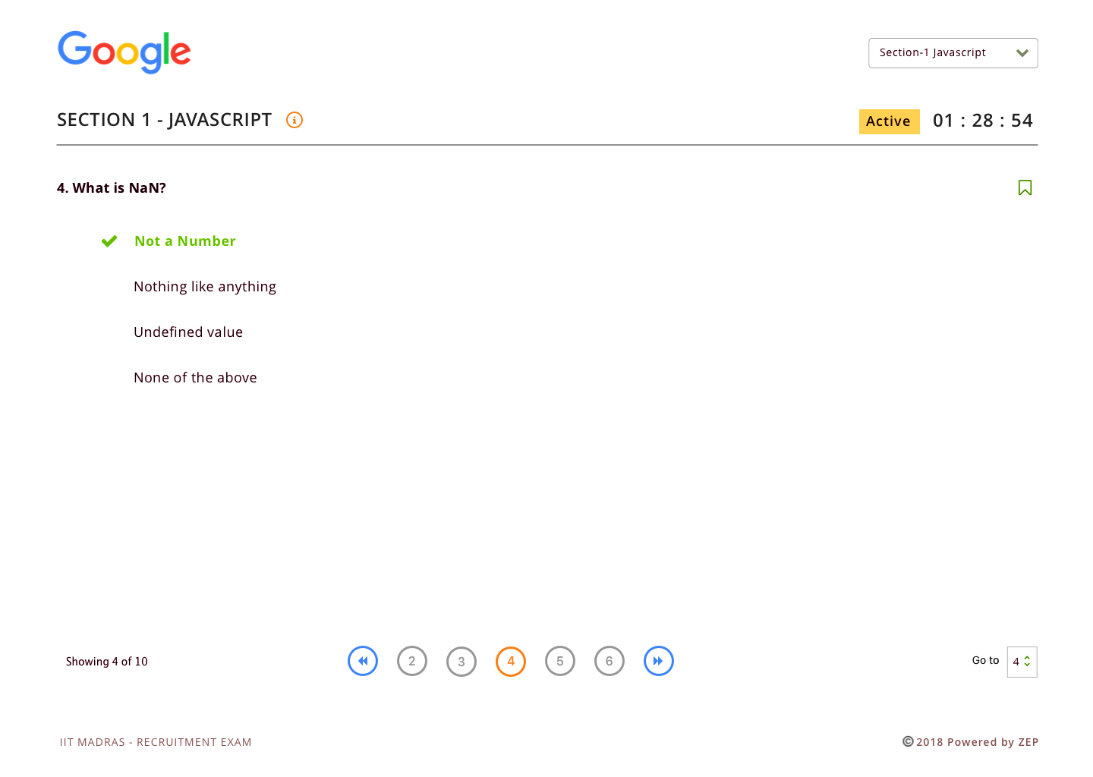

**Figure 6.4 Exam Screen-1**

**6.4.2 Exam Screen -2**

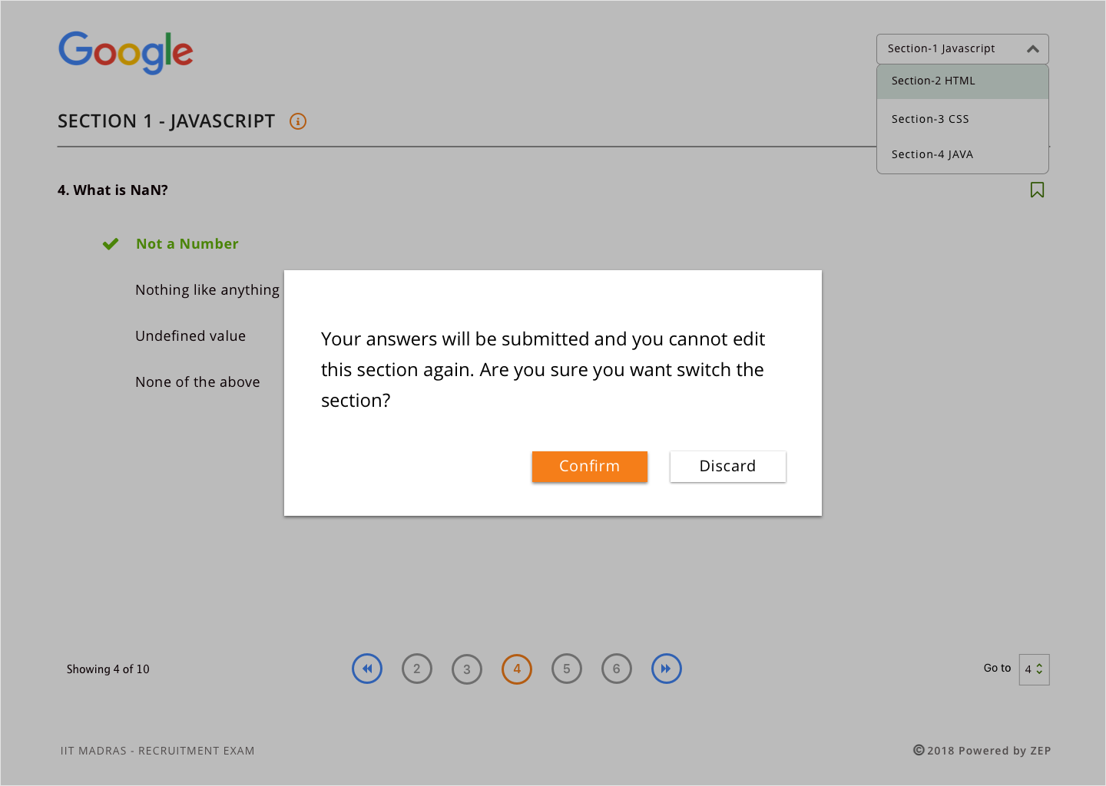

**Figure 6.5 Exam Screen-2**

**6.5 EXAM TEMPLATES LIST PAGE** 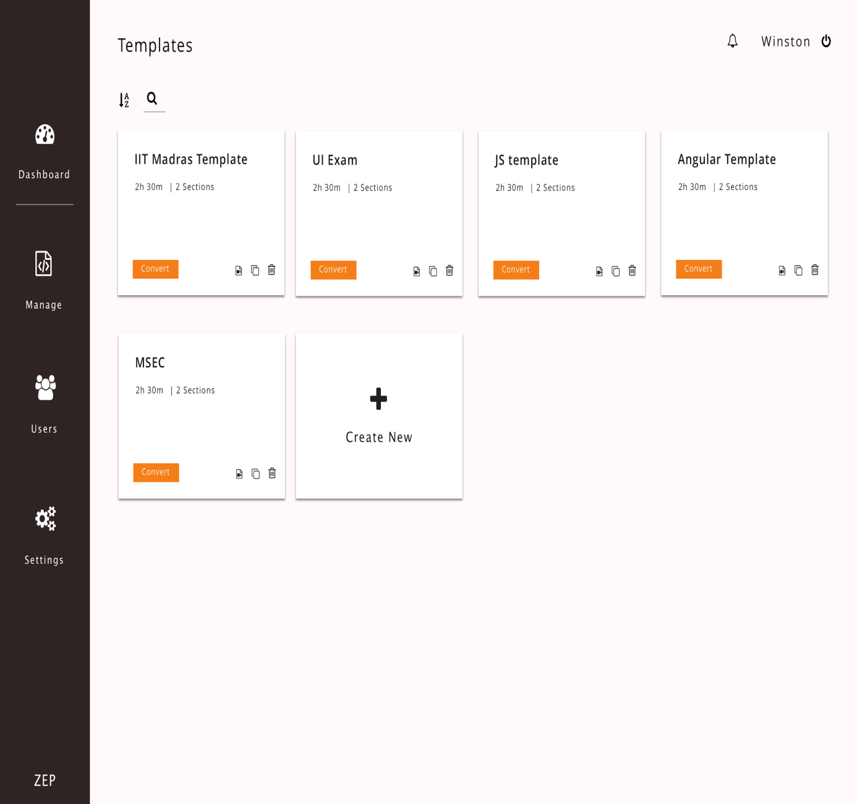

**Figure 6.6 Exam Templates List Page**

**6.6 EXAM TEMPLATE PAGE**

**6.6.1 Exam Template Page-1**

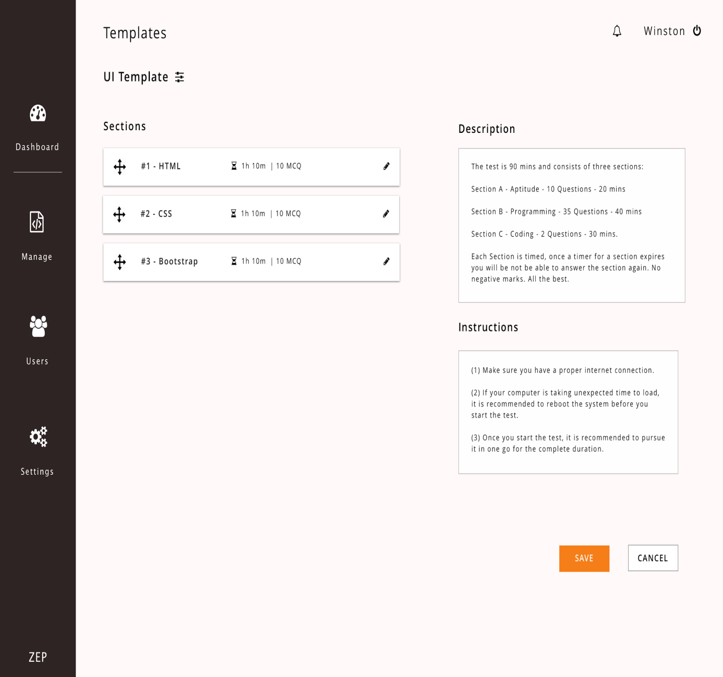

**Figure 6.7 Exam Template Page-1**

**6.6.2 Exam Template Page-2**

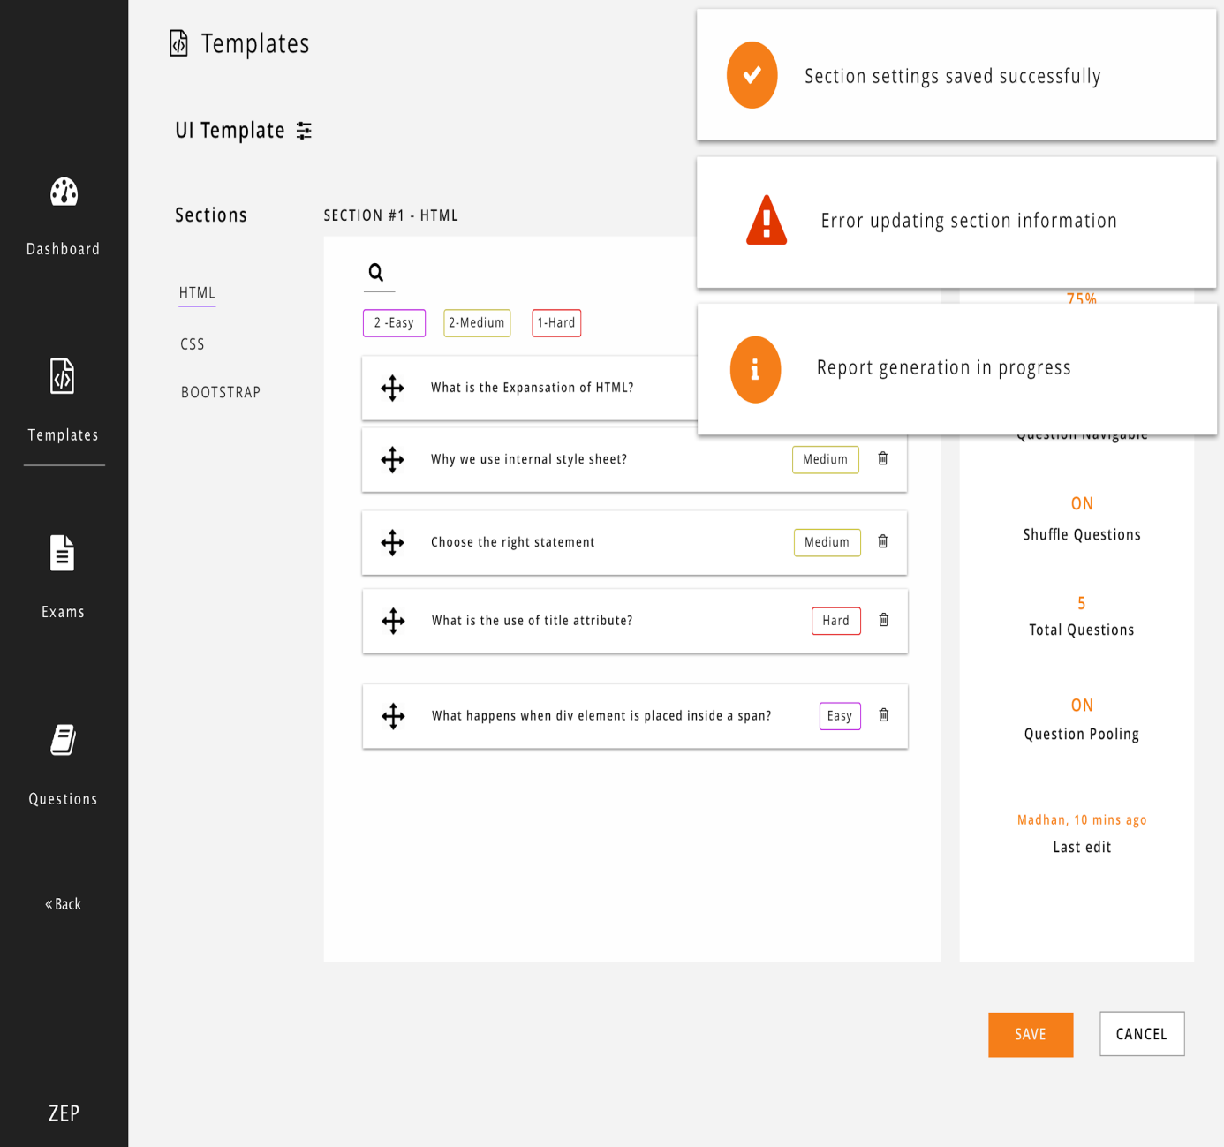

**Figure 6.8 Exam Template Page-2**

**6.7 EXAM TEMPLATE SETTINGS PAGE**

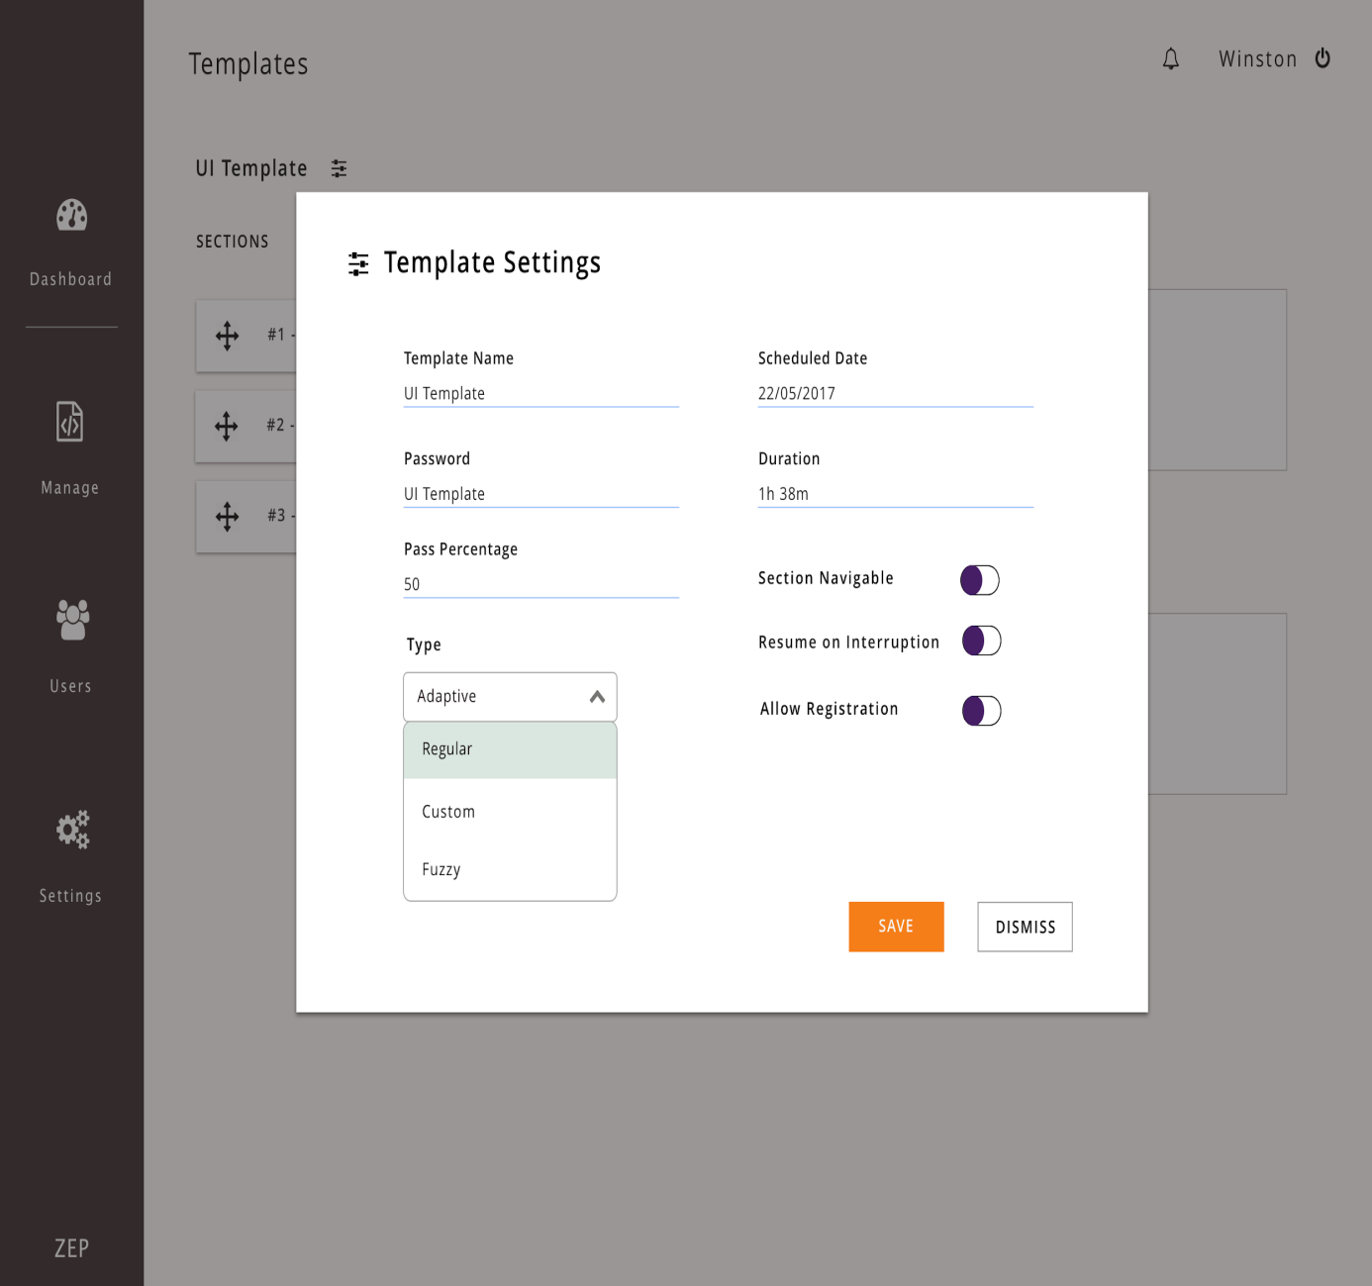

**Figure 6.9 Exam Template Settings Page**

**6.8 ADD QUESTIONS PAGE**

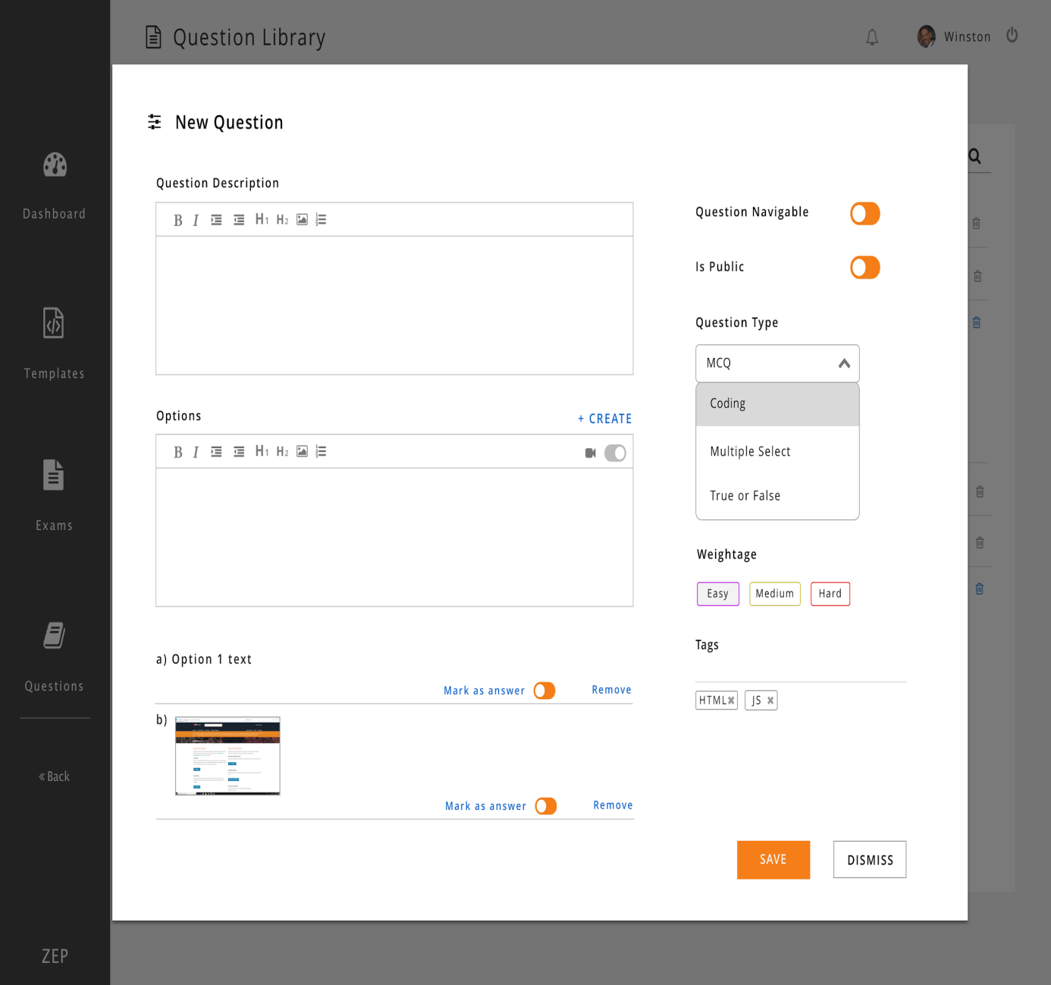

**Figure 6.10 Add Questions Page**

**6.9 QUESTION LIBRARY PAGE**

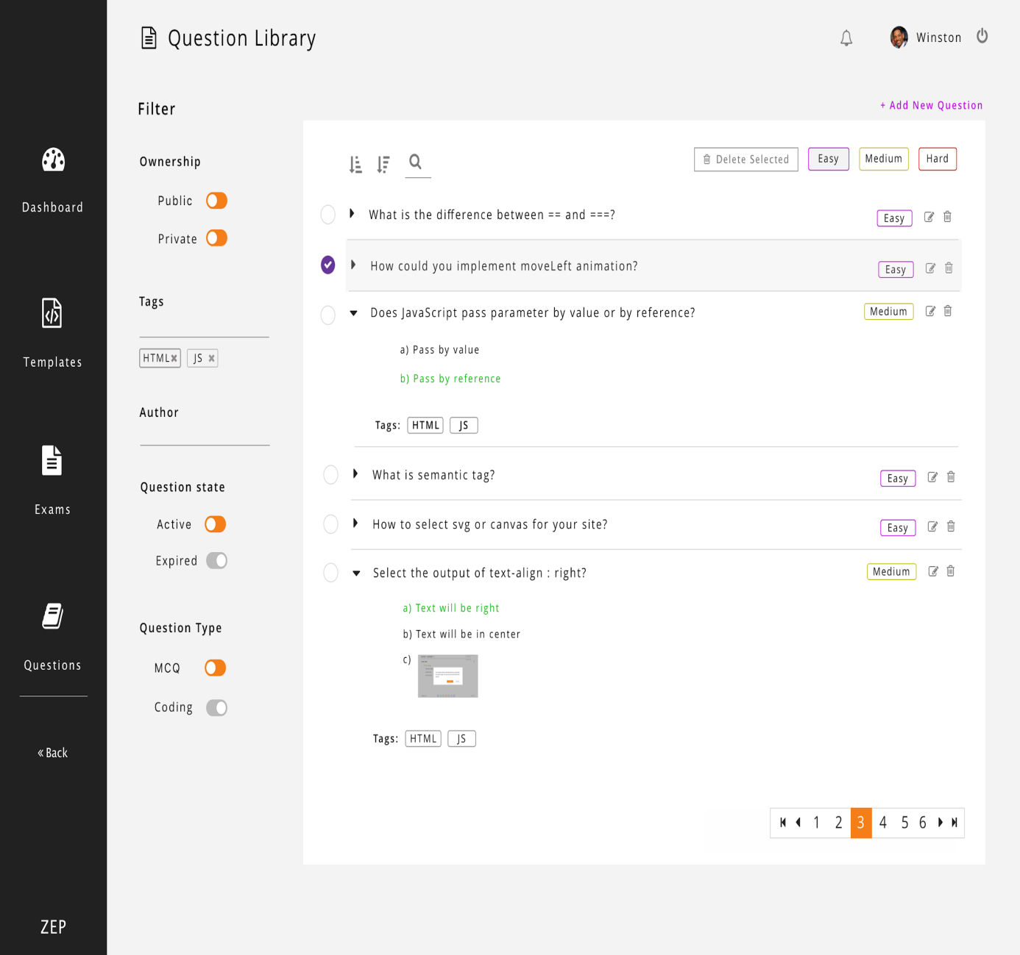

**Figure 6.11 Question library page**

**6.10 EXAM SUBMISSION PAGE**

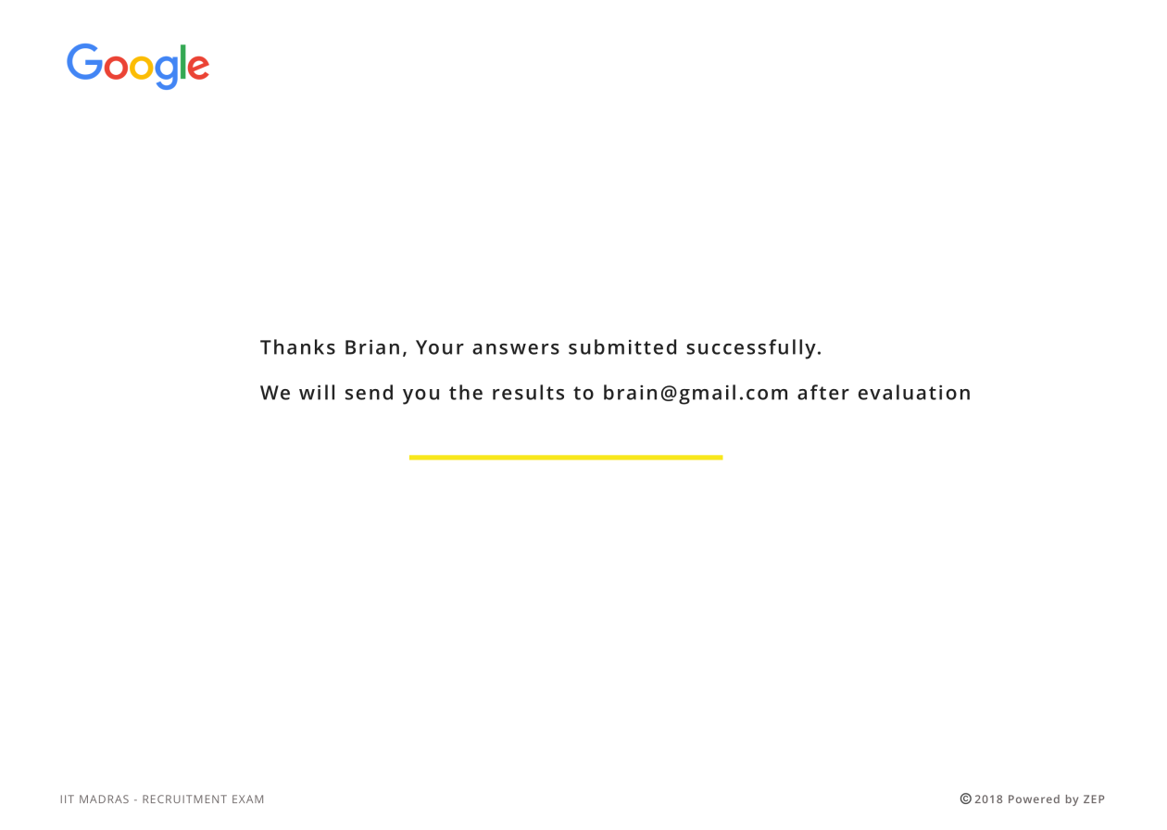

**Figure 6.12 Exam submission page**

**CHAPTER 6**

**CONCLUSION AND FUTURE WORK**

The adaptive assessment is developed to evaluate student performance and the developed system overcomes the drawbacks of the existing system which is not fully adaptive. Security measures are implemented to ensure the correct examinee attends the exam and the questions are given based on the answers of the student. The crashing of system is taken into account and session resumption is provided when needed. The examinee is prevented from navigating to other windows during the exam or changing the time duration. The assessment uses fuzzy logic to frame questions adaptively and hence filters students effectively.

The future scope is as follows:

* The work accomplished is that a single session is maintained for the user logging in with the same username and password. In typical web applications, user with a registered account can do two different logins from two different work locations and can maintain two concurrent sessions opened but, in some applications we want to limit the users to one session per account.
* Deliver exams securely for students with identity verification and cheating prevention algorithms. So that the verified candidates can take the exam from anywhere.

**REFERENCES**

1. Amin Zollanvari, Refik Caglar Kizilirmak, Yau Hee Kho, Daniel

Hernández-Torrano (2017) ‘Predicting Students’ Gpa And Developing

Intervention Strategies Based On Self-regulatory Learning Behaviors’,

IEEE Access Vol.5, pp. 23792-23802.

2. Anastasios Karakostas, Ioannis Magnisalis, Stavros Demetriadis.

(2011) ‘Adaptive And Intelligent Systems For Collaborative Learning

Support: A Review Of The Field’, IEEE Transactions on Learning

Technologies Vol.4, pp. 5 - 20.

3. Antonio Garrido, Lluvia Morales (2014) ‘E-learning And Intelligent

Planning: Improving Content Personalization’, IEEE Revista

Iberoamericana de Tecnologias del Aprendizaje Vol.9, pp: 1-7.

4. JianPing Zhang, Bo Mu, Shipin Chen (2009) ‘Design and Application

of a Response-Driven Adaptive Test System’,IEEE Information

Technology and Computer Science International Conference.

5. Jie Xu, Kyeong Ho Moon and Mihaela van der Schaar (2017) ‘A

Machine Learning Approach for Tracking and Predicting Student

Performance in Degree Programs’, IEEE Journal Of Selected Topics In

Signal Processing Vol.11, pp. 742-753.

6. G. Pankaj Jain, Varadraj P. Gurupur, Jennifer L. Schroeder, Eileen D.

Faulkenberry (2014) ‘Artificial Intelligence-based Student Learning

Evaluation: A Concept Map-based Approach For Analyzing A Student's Understanding Of A Topic’,IEEE Transactions On Learning

Technologies Vol.7, pp. 267-279.

7. https://www.docker.com/what-docker

8. http://microservices.io/

9. https://jwt.io

10. http://couchdb.apache.org/

11. https://redis.io/